Height of a Hollow Cylinder
# Source: AI Source: Provided by: [Data Path: Persons Table -> ID Column: 1, Name_En Column: Motasem Essam] -> From: [ChatGPT] on [7/25/2026]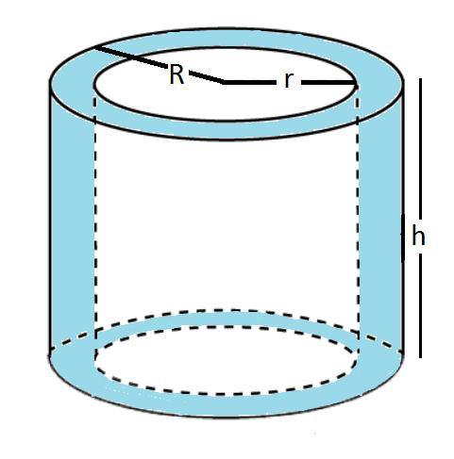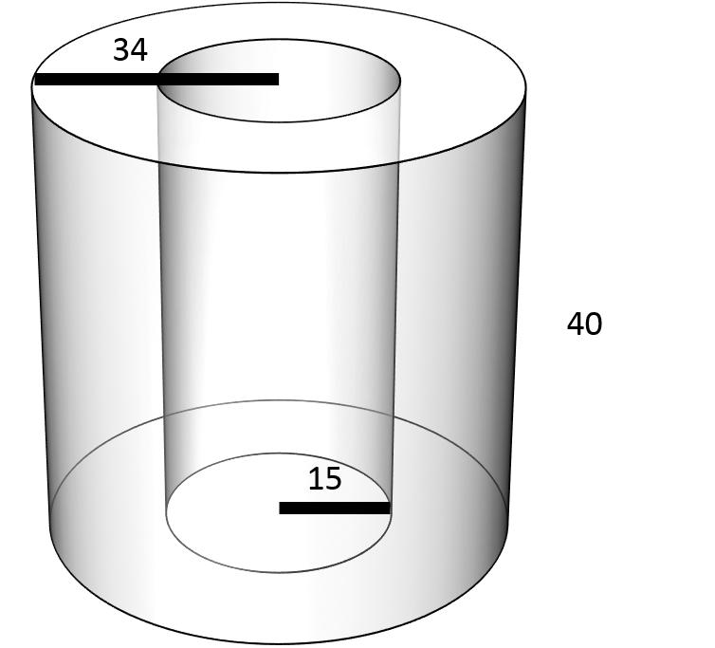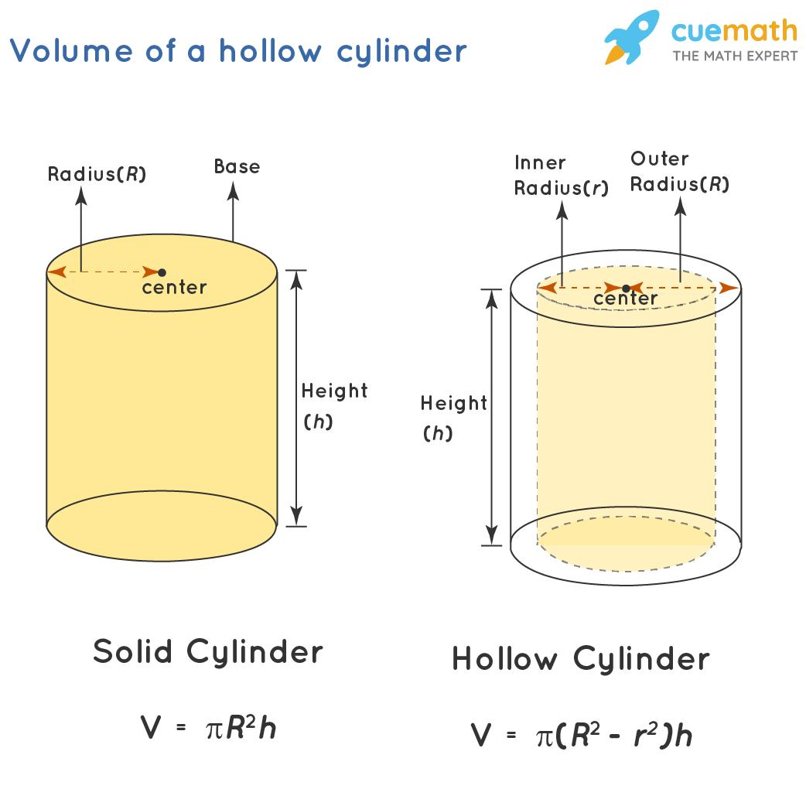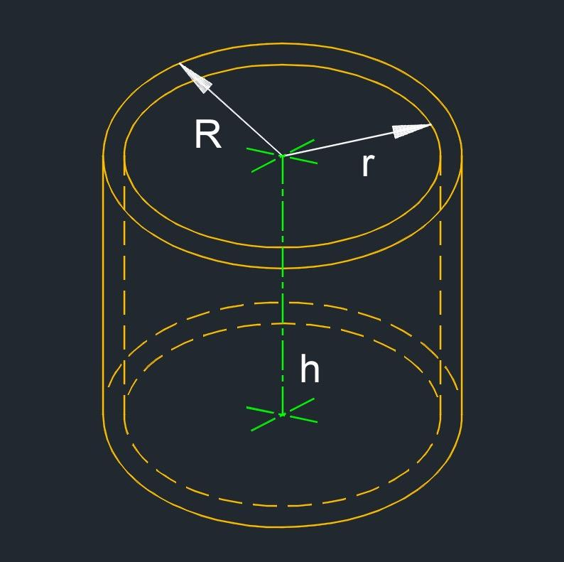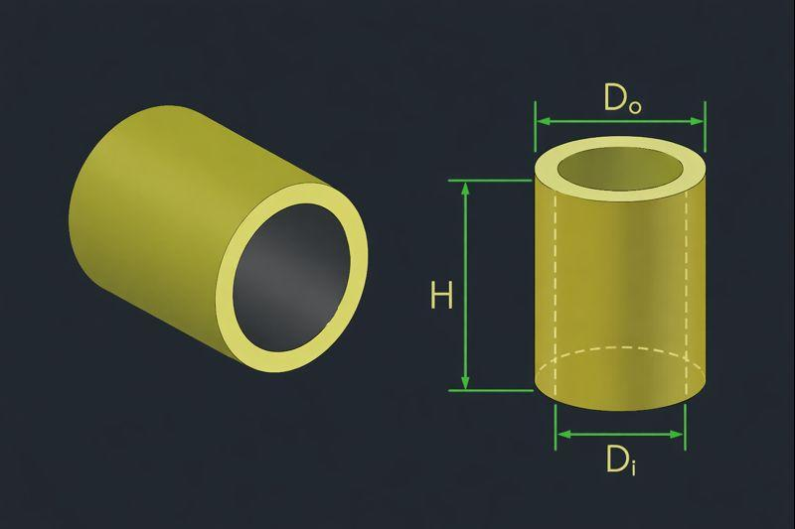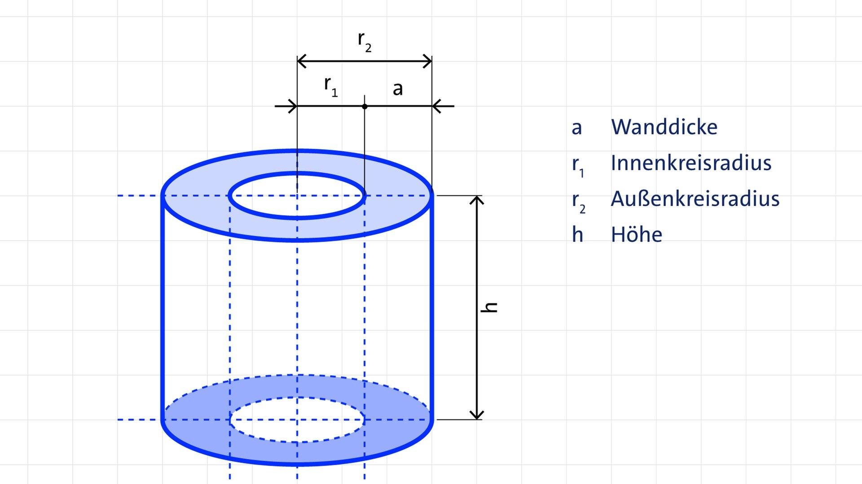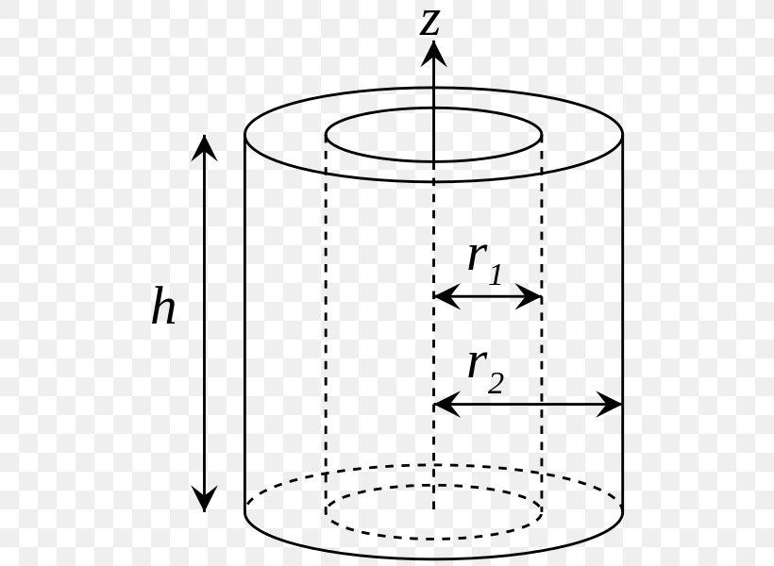

Definition
# Source: AI Source: Provided by: [Data Path: Persons Table -> ID Column: 1, Name_En Column: Motasem Essam] -> From: [ChatGPT] on [7/25/2026]
The height of a hollow cylinder is the perpendicular distance between the planes containing its two parallel annular ends (ring-shaped faces).
A hollow cylinder has an outer cylindrical surface and an inner cylindrical surface, separated by a wall of material. Its height measures the cylinder's axial extent, perpendicular to its end faces.
- Common symbols: $h$ or $H$
- Outer radius: $R$
- Inner radius: $r$, where $R>r$
- Wall thickness: $t=R-r$
- End faces: Annular regions between the outer and inner circles
For a right hollow circular cylinder, the height is equal to the length along its central axis. For an oblique hollow cylinder, the perpendicular height differs from the inclined axis length.

Simple Definition
# Source: AI Source: Provided by: [Data Path: Persons Table -> ID Column: 1, Name_En Column: Motasem Essam] -> From: [ChatGPT] on [7/25/2026]
The height of a hollow cylinder is the perpendicular distance from one ring-shaped end to the other. It is the cylinder's length measured along the perpendicular to its end faces, not the wall thickness.

Geometric Representation
# Source: AI Source: Provided by: [Data Path: Persons Table -> ID Column: 1, Name_En Column: Motasem Essam] -> From: [ChatGPT] on [7/25/2026]
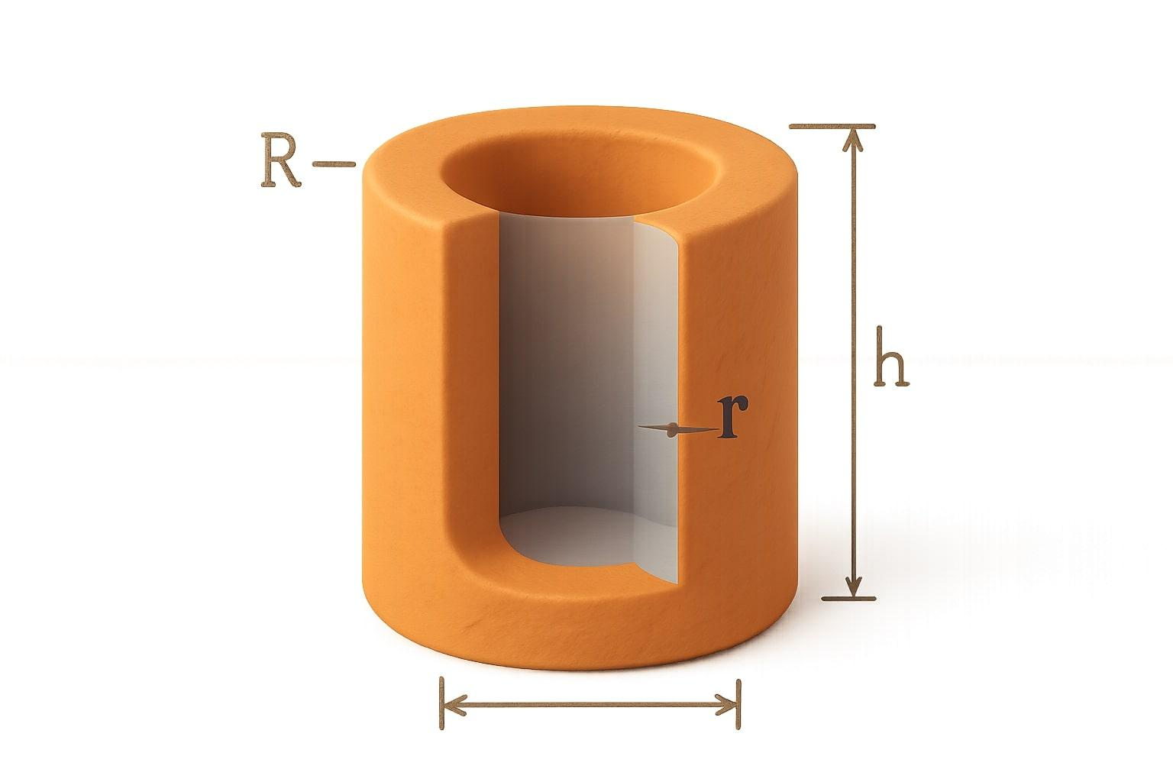
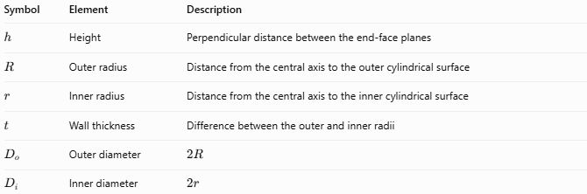
Symbol | Element | Description
$$h$$ | Height | Perpendicular distance between the end-face planes
$$R$$ | Outer radius | Distance from the central axis to the outer cylindrical surface
$$r$$ | Inner radius | Distance from the central axis to the inner cylindrical surface
$$t$$ | Wall thickness | Difference between the outer and inner radii
$$D_{o}$$ | Outer diameter | $$2R$$
$$D_{i}$$ | Inner diameter | $$2r$$
Important distinction: Height describes the length of the cylinder; wall thickness describes how thick the material is around the hollow interior.

Types and Geometric Cases
# Source: AI Source: Provided by: [Data Path: Persons Table -> ID Column: 1, Name_En Column: Motasem Essam] -> From: [ChatGPT] on [7/25/2026]
The height of a hollow cylinder can be considered in different configurations.

Height of a Right Hollow Cylinder
# Source: AI Source: Provided by: [Data Path: Persons Table -> ID Column: 1, Name_En Column: Motasem Essam] -> From: [ChatGPT] on [7/25/2026]
The end faces are perpendicular to the central axis. The perpendicular height equals the axial length.

Height of an Oblique Hollow Cylinder
# Source: AI Source: Provided by: [Data Path: Persons Table -> ID Column: 1, Name_En Column: Motasem Essam] -> From: [ChatGPT] on [7/25/2026]
The annular end faces are parallel, but the axis is inclined. The perpendicular height is shorter than the inclined axis length.
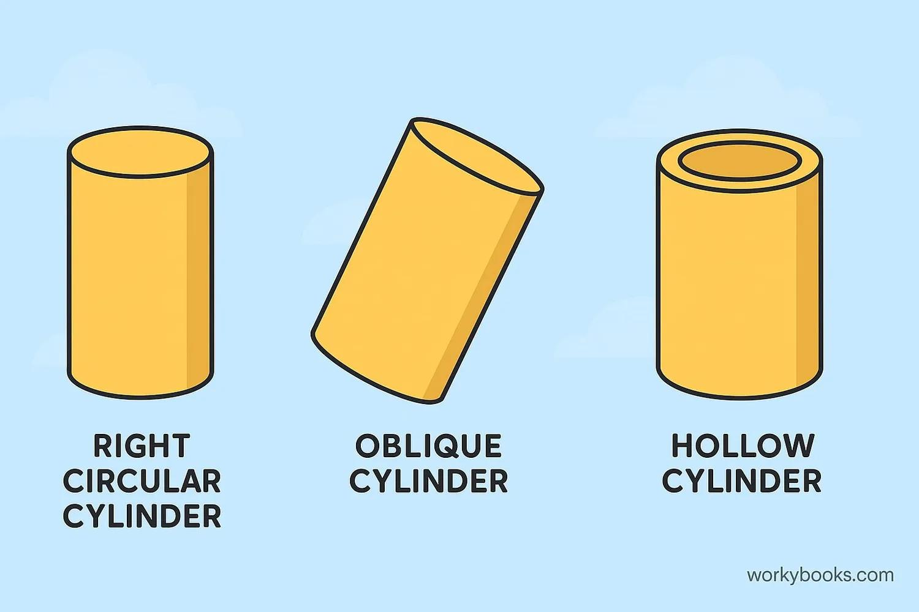

Height of a Long Hollow Cylinder
# Source: AI Source: Provided by: [Data Path: Persons Table -> ID Column: 1, Name_En Column: Motasem Essam] -> From: [ChatGPT] on [7/25/2026]
The height is much greater than the outer diameter. This is common in pipes, tubes, and cylindrical conduits.
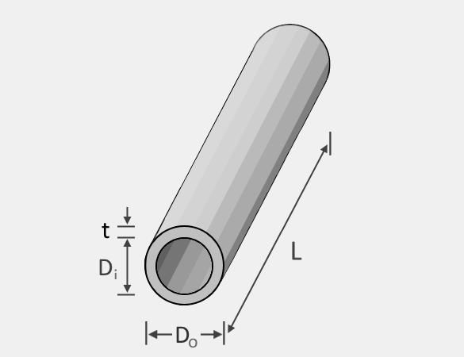

Mathematical Formulas

Height from the material volume
# Source: AI Source: Provided by: [Data Path: Persons Table -> ID Column: 1, Name_En Column: Motasem Essam] -> From: [ChatGPT] on [7/25/2026]
The volume of material in a hollow circular cylinder is the outer cylinder's volume minus the inner hollow space's volume:
$$V=πR^{2}h-πr^{2}h$$
Factor out the common terms:
$$V=πh(R^{2}-r^{2})$$
Therefore, the height is:
$$\boxed{h=\frac{V}{π(R^{2}-r^{2})}}$$
Where:
- $V$ = volume of the cylinder's material
- $R$ = outer radius
- $r$ = inner radius

Height using the diameters
# Source: AI Source: Provided by: [Data Path: Persons Table -> ID Column: 1, Name_En Column: Motasem Essam] -> From: [ChatGPT] on [7/25/2026]
Since $R=D_{o}/2$ and $r=D_{i}/2$:
$$V=\frac{πh}{4}(D_{o}^{2}-D_{i}^{2})$$
Rearranging:
$$\boxed{h=\frac{4V}{π(D_{o}^{2}-D_{i}^{2})}}$$

Height from the outer curved surface area
# Source: AI Source: Provided by: [Data Path: Persons Table -> ID Column: 1, Name_En Column: Motasem Essam] -> From: [ChatGPT] on [7/25/2026]
The outer curved surface area is:
$$S_{o}=2πRh$$
Thus:
$$\boxed{h=\frac{S_{o}}{2πR}}$$
Using the outer diameter:
$$\boxed{h=\frac{S_{o}}{πD_{o}}}$$

Height from the inner curved surface area
# Source: AI Source: Provided by: [Data Path: Persons Table -> ID Column: 1, Name_En Column: Motasem Essam] -> From: [ChatGPT] on [7/25/2026]
The inner curved surface area is:
$$S_{i}=2πrh$$
Therefore:
$$\boxed{h=\frac{S_{i}}{2πr}}$$
Or, using the inner diameter:
$$\boxed{h=\frac{S_{i}}{πD_{i}}}$$
These surface-area formulas assume the corresponding inner or outer cylindrical surface is fully included.

Worked Examples

Example 1 — Height from material volume
# Source: AI Source: Provided by: [Data Path: Persons Table -> ID Column: 1, Name_En Column: Motasem Essam] -> From: [ChatGPT] on [7/25/2026]
A hollow cylinder has an outer radius of $5 cm$, an inner radius of $3 cm$, and a material volume of $64π{ cm}^{3}$. Find its height.
Solution:
$$h=\frac{V}{π(R^{2}-r^{2})}$$
Substitute the given values:
$$h=\frac{64π}{π(5^{2}-3^{2})}$$
$$h=\frac{64}{25-9}=\frac{64}{16}$$
$$\boxed{h=4 cm}$$

Example 2 — Height from outer and inner diameters
# Source: AI Source: Provided by: [Data Path: Persons Table -> ID Column: 1, Name_En Column: Motasem Essam] -> From: [ChatGPT] on [7/25/2026]
A hollow cylinder has an outer diameter of $10 cm$, an inner diameter of $6 cm$, and a material volume of $64π{ cm}^{3}$. Calculate its height.
Solution:
$$h=\frac{4V}{π(D_{o}^{2}-D_{i}^{2})}$$
$$h=\frac{4(64π)}{π({10}^{2}-6^{2})}$$
$$h=\frac{256}{100-36}=\frac{256}{64}$$
$$\boxed{h=4 cm}$$

Example 3 — Height from outer curved surface area
# Source: AI Source: Provided by: [Data Path: Persons Table -> ID Column: 1, Name_En Column: Motasem Essam] -> From: [ChatGPT] on [7/25/2026]
A hollow cylinder has an outer radius of $4 cm$ and an outer curved surface area of $80π{ cm}^{2}$. Find its height.
Solution:
$$h=\frac{S_{o}}{2πR}$$
$$h=\frac{80π}{2π(4)}=\frac{80}{8}$$
$$\boxed{h=10 cm}$$

Key Characteristics
# Source: AI Source: Provided by: [Data Path: Persons Table -> ID Column: 1, Name_En Column: Motasem Essam] -> From: [ChatGPT] on [7/25/2026]
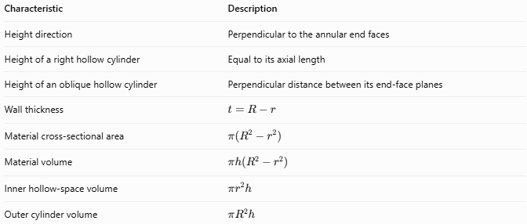
Characteristic | Description
Height direction | Perpendicular to the annular end faces
Height of a right hollow cylinder | Equal to its axial length
Height of an oblique hollow cylinder | Perpendicular distance between its end-face planes
Wall thickness | $$t=R-r$$
Material cross-sectional area | $$π(R^{2}-r^{2})$$
Material volume | $$πh(R^{2}-r^{2})$$
Inner hollow-space volume | $$πr^{2}h$$
Outer cylinder volume | $$πR^{2}h$$

Comparison with Related Measurements
# Source: AI Source: Provided by: [Data Path: Persons Table -> ID Column: 1, Name_En Column: Motasem Essam] -> From: [ChatGPT] on [7/25/2026]
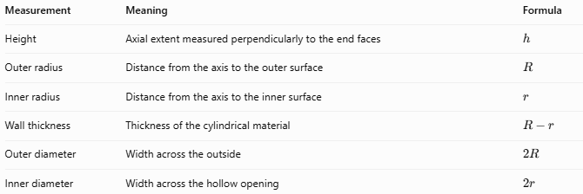
Measurement | Meaning | Formula
Height | Axial extent measured perpendicularly to the end faces | $$h$$
Outer radius | Distance from the axis to the outer surface | $$R$$
Inner radius | Distance from the axis to the inner surface | $$r$$
Wall thickness | Thickness of the cylindrical material | $$R-r$$
Outer diameter | Width across the outside | $$2R$$
Inner diameter | Width across the hollow opening | $$2r$$

Applications
# Source: AI Source: Provided by: [Data Path: Persons Table -> ID Column: 1, Name_En Column: Motasem Essam] -> From: [ChatGPT] on [7/25/2026]
The height of a hollow cylinder is useful when calculating:
- The material required to manufacture pipes and metal tubes.
- The volume and capacity of cylindrical components.
- The external and internal surface areas of tubes.
- The dimensions of hollow shafts and cylindrical sleeves.
- The material volume and mass of hollow cylindrical structures.
For mass calculations, once the material volume is known:
$$m=ρV$$
where $m$ is mass and $ρ$ is the material density.

Key Points
# Source: AI Source: Provided by: [Data Path: Persons Table -> ID Column: 1, Name_En Column: Motasem Essam] -> From: [ChatGPT] on [7/25/2026]
- The height is the perpendicular distance between the two annular end faces.
- The height is not the wall thickness.
- For a right hollow cylinder, height equals axial length.
- The material volume is $V=πh(R^{2}-r^{2})$.
- The height can be found from material volume, radii, diameters, or a suitable curved surface area.
- For an oblique hollow cylinder, distinguish perpendicular height from inclined axis length.

Conclusion
# Source: AI Source: Provided by: [Data Path: Persons Table -> ID Column: 1, Name_En Column: Motasem Essam] -> From: [ChatGPT] on [7/25/2026]
The height of a hollow cylinder measures the perpendicular distance between its two ring-shaped ends. It is an essential dimension for calculating the cylinder's material volume, surface areas, capacity, and mass. The hollow interior must be accounted for when calculating the material volume.

